

**ExpressTime Mobile requires 2 settings to be configured correctly on iPhone:**

1. Click on the **Settings** icon & then click on **Privacy**.
2. **Location Services -** toggle **On** & Set to **Always**.

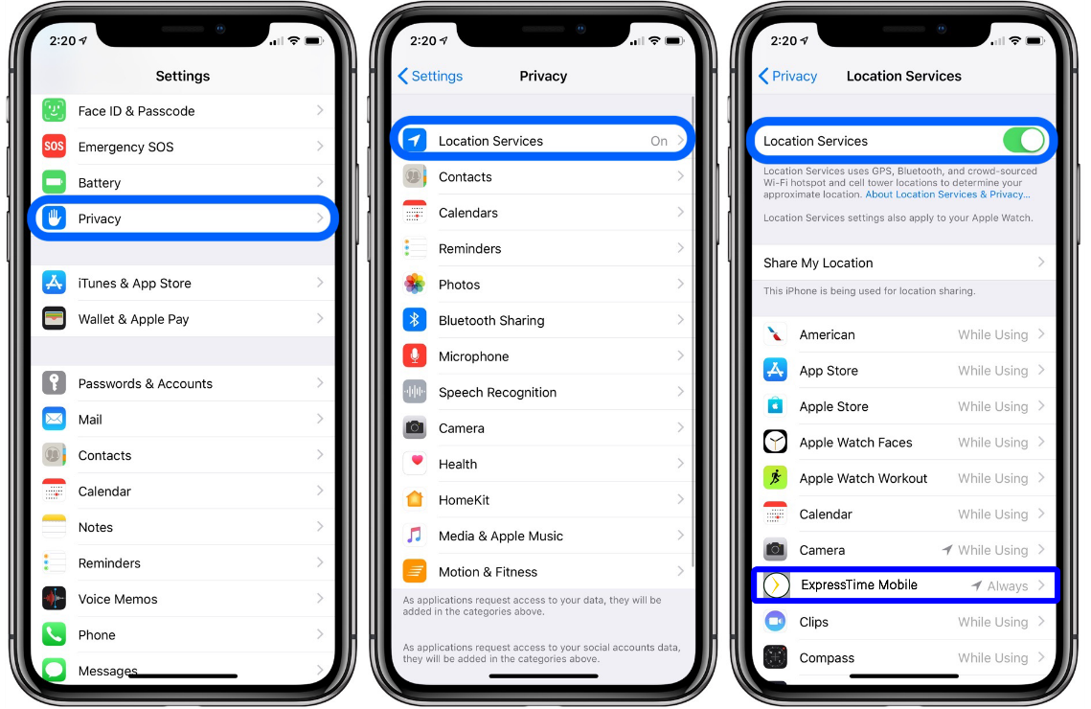

1. **App Tracking** – toggle **On** for ExpressTime Mobile.

